Practical 07
Name:- Mo Atif Azmi
Batch:-A4_B4_51
Date:-29-10-2025

Aim:- Aim: Implement Hamiltonian Cycle using Backtracking.
Problem Statement:
The Smart City Transportation Department is designing a night-patrol route for security vehicles. Each area of the city is represented as a vertex in a graph, and a road between two areas is represented as an edge. The goal is to find a route that starts from the main headquarters (Area A), visits each area exactly once, and returns back to the headquarters — forming a Hamiltonian Cycle. If such a route is not possible, display a suitable message.

Code:- def is_safe(vertex, graph, path, position):
if graph[path[position - 1]][vertex] == 0:
return False
if vertex in path:
return False
return True
def ham_cycle_util(graph, path, position):
n = len(graph)
if position == n:
if graph[path[position - 1]][path[0]] == 1:
return True
else:
return False
for vertex in range(1, n):
if is_safe(vertex, graph, path, position):
path[position] = vertex
if ham_cycle_util(graph, path, position + 1):
return True
path[position] = -1
return False
def ham_cycle(graph):
n = len(graph)
path = [-1] * n
path[0] = 0
if not ham_cycle_util(graph, path, 1):
print("No Hamiltonian Cycle exists")
return False
print("Hamiltonian Cycle found:")
for vertex in path:
print(chr(65 + vertex), end=" -> ")
print(chr(65 + path[0]))
return True
if __name__ == "__main__":
graph = [
[0, 1, 1, 0, 1],
[1, 0, 1, 1, 0],
[1, 1, 0, 1, 0],
[0, 1, 1, 0, 1],
[1, 0, 0, 1, 0]
]
ham_cycle(graph)

output;-
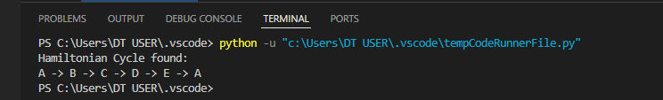
practical No 7:
Competitive Coding Link:
https://www.geeksforgeeks.org/problems/hamiltonian-path2522/1
PS:-
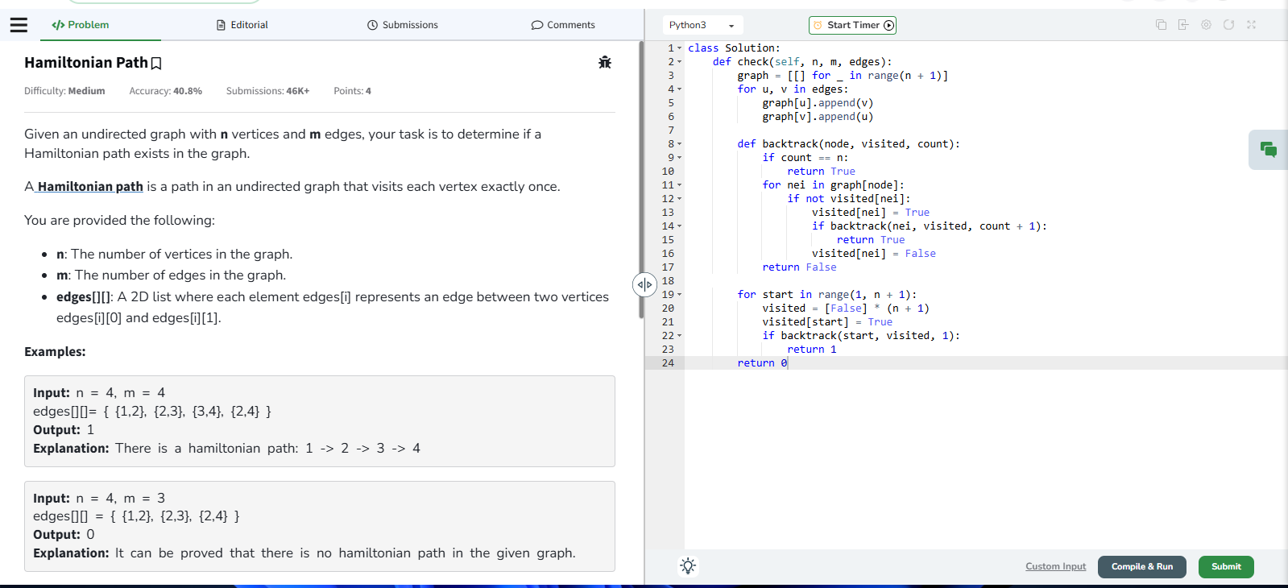
Output:-
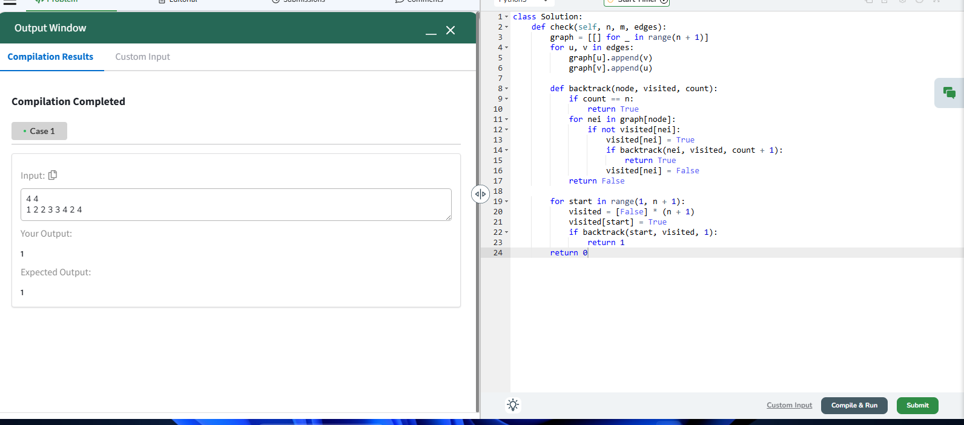
Submission link:- https://www.geeksforgeeks.org/problems/hamiltonian-path2522/1

